맵 예시(마블 미드나잇 선즈)

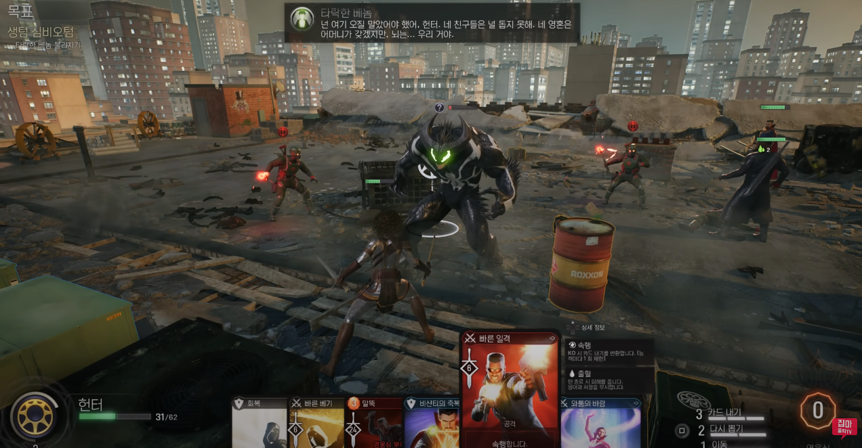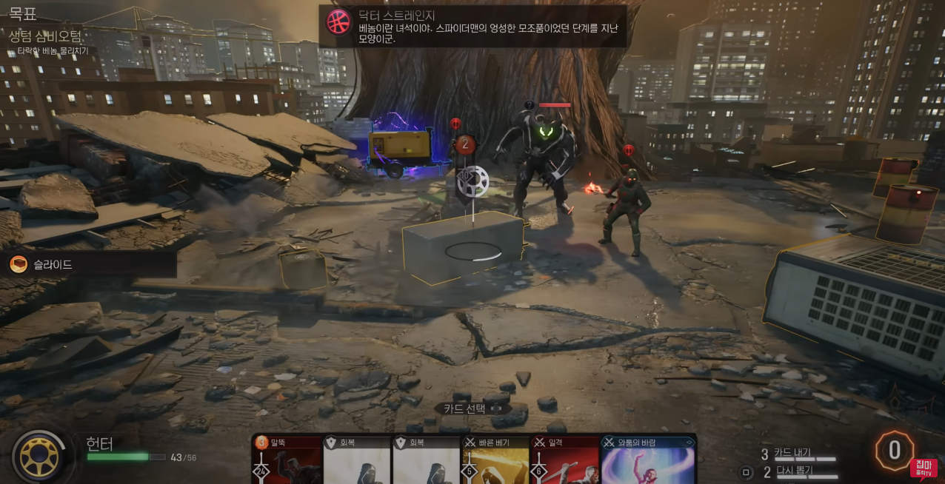

|  |  |  |
| --- | --- | --- |
| 이미지 | 이름 | 타입 |
| Old metal barrel oil isolated on white background, with clipping path Stock  Photo by ©dusan964 82397838 | Barrel | Destructible Object |
| 10,479 Air Conditioner Outdoor Unit Images, Stock Photos & Vectors |  Shutterstock | Outdoor Unit | Movable Object |
| F:\TeamProjectResource\Building\Building N250221\111a.jpg | Building\_1 | Background Object |
| F:\TeamProjectResource\Building\Building3\ddd.jpg | Building\_2 | Background Object |
| F:\TeamProjectResource\Building\Building4\Building 1 640 x 480 px.jpg | Building\_3 | Background Object |
|  | Building\_4 | Background Object |
|  | Building\_5 | Background Object |
| Tool for creating texture for skybox - Unity Answers | Skyscraper | Sky Box Texture |
| F:\TeamProjectResource\Texture\PaintedMetal006_1K-JPG\PaintedMetal006_1K_Color.jpg | Painted Metal | Rooftop Tile Texture |
|  | Painted Plaster | Rooftop Tile Texture |
| C:\Users\Dongwan\AppData\Local\Microsoft\Windows\INetCache\Content.Word\Rock016_PREVIEW.JPG | Rock\_1 | Rooftop Tile Texture |
| C:\Users\Dongwan\AppData\Local\Microsoft\Windows\INetCache\Content.Word\Rock024_PREVIEW.JPG | Rock\_2 | Rooftop Tile Texture |
| C:\Users\Dongwan\AppData\Local\Microsoft\Windows\INetCache\Content.Word\Rock030_PREVIEW.JPG | Rock\_3 | Rooftop Tile Texture |